**South Columbus FFA Good News 2/21/2013** 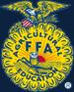

**Raleigh-**

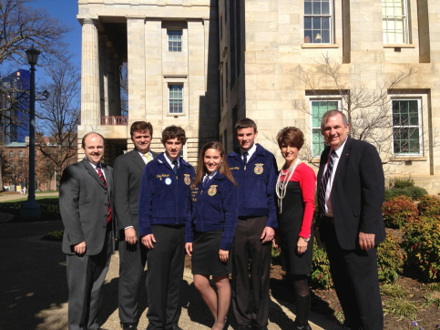The South Columbus FFA teamed up with over 300 members from across the state on Tuesday, February 12th for the Inaugural FFA Day at the North Carolina Legislature. South Columbus members Olivia Watson, Cody Jackson and Brandon Long joined their FFA Advisors Marlette Watson and Berry Strickland for a fast paced day which began with a breakfast meeting with the Senate Agriculture Appropriations Committee where the students were engaged in conversation with state Senators and answering countless questions regarding their Agricultural Education program and focusing on the future of agriculture in North Carolina.

Students later met with our own House Member, Ken Waddell, former Agriculture Teacher from East Columbus High School who was instrumental in establishing a meeting of the House Agriculture Appropriations committee where Olivia was recognized and delivered her First Place Winning Prepared Public Speaking Address entitled ***“The Thin Green Line”.*** The committee members and over 75 guests gave a standing ovation after Olivia’s oratorical delivery. The committee also presented Olivia with a House Resolution recognizing the importance of Agricultural and the FFA in public schools.

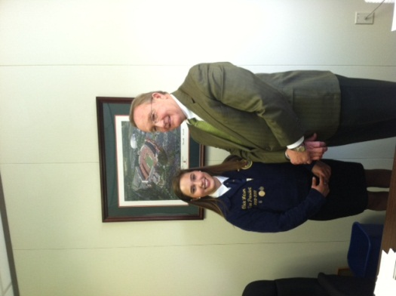The team met with Senator Michael Walters to discuss Agricultural Education and the FFA and received a warm welcome as he also introduced the team to his committee the “*Agriculture/Environmental and Natural Resources Committee*”. They invited Olivia to speak to the entire group and present her speech to their group. This meeting included the entire Agriculture/Environmental and Natural Resources Committee, other members of the State Senate, Commissioner of Agriculture and numerous media venues. After receiving another standing ovation for her presentation, Olivia again was presented a certificate of appreciation by the speaker and was personally applauded by the Commission of Agriculture, Steve Troxler who had the unfortunate job of following Olivia presentation with his own address to the committee.

As students from around the state gathered at the Legislative Building to view the Senate and House from the Rotunda, our students were invited into the both chambers as a resolution was read and adopted declaring that week as State FFA and Agricultural Education Week across the state. After a unanimous vote to adopt the resolution, our members were recognized by the speakers and we again received standing ovations for representing the States FFA Association and for making a positive impact on all present in both the Senate and House of this momentous and historical day in North Carolina Government.

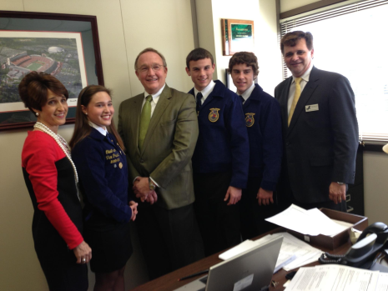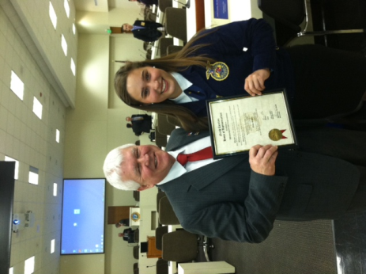Olivia placed First in the North Carolina FFA Prepared Public Speaking Event held at the 85th State FFA Convention in June of last year, she also received a bronze medal at the National FFA Prepared Public Speaking Contest in October which was held at the 85th National FFA Convention in Indianapolis, Indiana. Event participants were required to deliver a prepared speech on one agricultural topic. The speech must be six to eight minutes in length. After the speech is given, judges question the speaker for five minutes. Winners are selected on the written manuscript, speech delivery, content and response to judges’ questions.

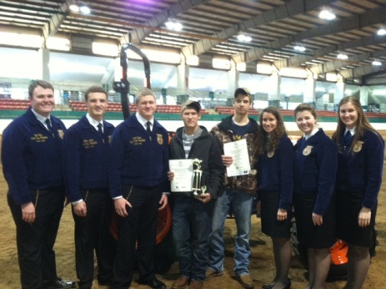Devin White and Christian Coleman represented South Columbus and the Three Rivers Federation FFA at the State Level FFA Truck and Tractor Driving Contest which was held at the NC State Fairgrounds, Hunt Horse Area, on October 31st. Over 140 participants from across the state participated in this all day safety event. Devin White placed First in the State in Truck Safety. Devin will be recognized on stage at the NC FFA State Convention in June.

The North Carolina FFA is a youth organization of over 17,400 student members preparing for leadership and careers in the science, business and technology of agriculture with nearly 250 local chapters across the state. FFA makes a positive difference in the lives of students by developing their potential for **premier leadership, personal growth and career success** through agricultural education. Visit www.ncffa.org for more information.