
2020-2021

STUDENT/PARENT HANDBOOK

Dear Parents & Students,
On behalf of our faculty and staff, I am pleased to welcome you to Nakina Middle School for another exciting and invigorating school year full of endless possibilities. It is because of your loyalty and commitment that Nakina Middle School has a rich tradition of excellence in academics and athletics. With the continued hard work, self-discipline and individual responsibility of the student body, Nakina Middle will continue to grow mature and dependable adults ready to succeed in the ever changing global society.
The administration and the faculty want students to be successful at school. Experience has shown that successful students are those who enter wholeheartedly in the total school program, who work conscientiously to master the scholastic work, participate in activities, cooperate in projects, and take pride in their daily performance. The successful student is a student who helps others feel at home. This student is considerate and respects the rights of others and the authority of his/her teachers. He/She cheerfully carries their load and is slow to complain. This student criticizes only when he/she sees a way to make improvement.
Serving as principal at Nakina Middle School is a wonderful opportunity which I welcome and value. I am honored to be a part of a school and community where the tradition of excellence is expected, and I am committed to build upon that foundation as we aspire for greater accomplishments in the future.
I look forward to the future successes we will accomplish together.
Please accept this invitation to contact me as the need arises. My e-mail address is dboyd@columbus.k12.nc.us or you can contact me by telephone at 642-8301. Thank you in advance for your support as we make this our best year yet!
Respectfully,
Derrick Boyd
Derrick Boyd, M.S.A
Principal, Nakina Middle School

Mission Statement
Nakina Middle School is committed to creating high academic and social expectations for our school and community while preparing the individual student to be a productive citizen in the ever changing 21st century.
Vision
Students will be prepared to live, work and contribute in a global society.
BELL SCHEDULE 2020-2021
7:45 Teachers Arrive
8:00 First bell rings to report to Homeroom
8:13 Tardy Bell Rings (Students must sign in at the main office and receive tardy note)
3:00 Dismissal Bell Rings

SCHOOL VOLUNTEERS
The board recognizes the valuable contributions that school volunteers make to the learning process and the educational goals of the school system. Instructional programs are enhanced through the contributions of students’ parents, community members, and local business and industry. These volunteers contribute time, resources, and expertise that assist the school system to reach the goal of providing a sound basic education to all children.
The board encourages school administrators to develop and implement plans and procedures for utilizing school volunteers. The superintendent and designees shall be responsible for the implementing and supervising school volunteer programs. School volunteer programs must provide the following:
1. Adequate screening of volunteers based upon the amount of contact they will have with students;
2. All volunteers shall be subject to a criminal background check (performed by Columbus County Schools) for which they are financially responsible ($10.00 per person at the beginning of the school year)
3. The requirement that volunteers comply with policy 5015, Visitors to the Schools:
4. Reasonable supervision of volunteers based at least in part upon the amount of contact they will have with students; and adequate training of volunteers, including familiarizing volunteers with applicable laws, board policies, administrative procedures and school rules.
Individuals selected as school volunteers must be recommended by the school principal and superintendent and approved by the board before beginning services as a volunteer. All school volunteers shall be expected to be professional and dependable in their volunteer activities.
Legal References: G.S. 115C-36, -47, -203 to -209.1
Cross References: Parental Involvement (policy 1310/4002), Visitors to the School (policy 5015)
Adopted: March 29, 2010

NOTIFICATION OF RIGHTS UNDER FERPA FOR ELEMNTARY AND SECONDARY SCHOOLS
The Family Educational Rights and Privacy Act (FERPA) afford parents and students over 19 years of age (“eligible students”) certain rights with respect to the student’s education records. These rights are:
- The right to inspect and review the student’s education records within 45 days of the day the school receives a request for access.
Parents or eligible students should submit to the school principal or appropriate school official a written request that identifies the record(s) they wish to inspect. The school official will make arrangements for access and notify the parent or eligible student of the time and place where the record may be inspected.
- The right to request the amendment of the student’s education records that the parent or eligible student believes are inaccurate, misleading, or otherwise in violation of student’s privacy rights under FERPA.
Parents or eligible students who wish to ask the school to amend a record should write the school principal or appropriate school official, clearly identify the part of the record they want changed, and specify why it should be changed. If the school decides not to amend the record as requested by the parent or eligible student, the school will notify the parents or the eligible student of the decision and advise them of their right to a hearing regarding the request for amendment. Additional information regarding the hearing procedures will be provided to the parent or eligible students when notified of the right to a hearing.
- The right to consent to disclosure of personally identifiable information contained in the student’s education records, except to the extent that FERPA authorizes disclosure without consent.
On exception, which permits disclosure without consent, is disclosure to school official with legitimate educational interests. A school official is a person employed by the school as an administrator, supervisor, instructor, or support staff member (including health or medical staff and law enforcement unit personnel); a person serving on the school board; a person or company with whom the school has contracted as its agent to provide a service instead of using its own employees or officials (such as an attorney, auditor, medical consultant, or therapist); or a parent or student serving on an official committee, such as a disciplinary or grievance committee, or assisting another school official in performing his or her tasks.
A school official has a legitimate educational interest if the official needs to review an education record in order to fulfill his or her professional responsibility.
- The right to file a complaint with the U.S. Department of Education concerning alleged failure by Columbus County Schools to comply with the requirements of FERPA. The name and address of the Office that administers FERPA are:
Family Policy Compliance Office
U.S. Department of Education
400 Maryland Avenue, SW
Washington, DC 20020-5920

NOTIFICATION OF RIGHTS UNDER THE PROTECTION OF PUPIL RIGHTS AMENDMENT (PPRA)
PPRA affords parents and students who are 18 or emancipated minors (“eligible students”) certain rights regarding our conduct of surveys, collection and use of information for marketing purposes, and certain physical exams. A copy of the school system’s policy regarding PPRA can be obtained in the principal’s office. These include the right to:
-Consent before students are required to submit to a survey that concerns one or more of the following protected areas (“protected information survey”) if the survey is funded in whole or in part by a program of the U.S. Dept. of Education:
1. Political affiliations or beliefs of the student or student’s parent;
2. Mental or psychological problems or the student or student’s family;
3. Sex behavior or attitudes;
4. Illegal, anti-social, self-incriminating, or demeaning behavior;
5. Critical appraisals of others with whom respondents have close family relationships:
6. Legally recognized privileged relationships, such as with lawyers, doctors, or ministers;
7. Religious practices, affiliations, or beliefs of the student or parents; or
8. Income, other than as required by law to determine program eligibility.
-Receive notice and an opportunity to opt a student out of:
1. Any other protected information survey, regardless of funding;
2. Any non-emergency, invasive physical exam or screening required as a condition of attendance, administered by the school or its agent, and not necessary to protect the immediate health and safety of a student, except for hearing, vision, or scoliosis screenings, or any physical exam or screening permitted or required under State law; and
3. Activities involving collection, disclosure, or use of personal information obtained from students for marketing or to sell or otherwise distribute the information to others.
-Inspect, upon request and before administration or use:
1. Protected information surveys of students;
2. Instruments used to collect personal information from students for any of the above marketing, sales, or other distribution purposes; and
3. Instructional material used as part of the education curriculum.

FEDERAL COORDINATORS
Section 504 (Rehabilitation Act), Eddie Beck, Board of Education
As required by Federal regulations, you are notified by this memo that an asbestos management plan for your school has been developed. It is on file in the principal’s office and is available for public view. A copy is also on file at the office of the superintendent.

DISCIPLINE PROGRAM
We believe students should conduct themselves appropriately at all times and should be responsible for their actions. Behavior should not prevent teaching or students from learning. In order to encourage good behavior and maintain an environment conducive to learning, procedures/agreements are necessary.
Classroom procedures/agreements will be developed by each individual class during the first week of school. All students are expected to follow these general procedures/agreements.
- Follow directions the first time they are given.
- Keep your hands, arms, and feet to yourself.
- Respect others and their property.
- Be Ready, Responsible, and Respectful.
Possible discipline action if referred to the office would be:
- Administrative conference
- OSS (Out of School Suspension)
Administrative/Parent Conferences may be scheduled after 3:00 pm.
Students are also expected to comply with the district’s policies and procedures regarding student discipline. These may be found in your copy of the Student Rules and regulations or online at www.columbus.k12.nc.us.

MEDICATION ADMINISTRATION POLICY
Medications administered during school hours by school personnel should be kept to a minimum. The student in need of medication to sustain his attendance in school may have a chronic health problem, special health care need, or have an unusual health problem where emergency measures are indicated. The policy is intended for this type child. The school will assume no responsibility for students who self-medicate. This is the responsibility of the student’s parents or guardians.
1. Acutely ill children may need medication for short periods of time to enable them to remain in school. Medications should be given at home before or after school hours. If this is not possible, it is the parent’s or guardian’s responsibility to make arrangements with school administration for medication to be given during school hours.
2. When medications such as asthma inhalers must be self-administered, an individualized plan, an authorization form completed by the parent and physician and competency of the student verified by physician with final review by school nurse will be secured. Students will agree to keep their medications secure from other students.
3. When children who are subject to unusual health hazards (such as allergy to bee stings when use of Epi-pen is needed) attend school, it is the parent’s or guardian’s responsibility to assure that the school administration is aware of the situation and is prepared to implement emergency measures. The plan (developed between the student’s parent or guardian, personal physician or health care source, and the school) for responding to such an emergency may include:
• administering medication to slow allergic reactions until the student can be transported to the physician’s office, or emergency room, or
• instituting first-aid measures.
This should be included in an individualized written emergency plan developed for the student, and approved by the parent or guardian and physician. The after care of the student is determined by the attending physician who sees the student either in the office or in the emergency room. The parent or guardian has responsibility for assuring that an emergency care plan is developed for the child, and that written permission is given by them to institute emergency measures.
Parent or Guardian’s Responsibility
Come to school and administer medications to their child as prescribed OR
1. Obtain a “Request for Medication to be Given During School Hours” (from the school) and have the child’s doctor complete the indicated information. A separate form is required for each medication. Sign the form and return it to the school.
2. Provide prescription medication in a labeled container which includes:
• the child’s name
• the name of the medication
• the unit dosage to be given (ex: 10 mg.)
• the number of dosage units (ex: 30 tablets)
• the time the medication is to be given
• how the medication is to be administered (ex: oral, topical, inhaled, injection)
Over-the counter medication should be in the original container and labeled with the child’s name.
3. If the medication is needed at school and home, have the pharmacist label two containers (one for each place).
4. Maintain an adequate supply of medication at the school. The parent/guardian must deliver the medication to school. In the event that transmittal of the medication to the school presents an undue hardship for the parent/guardian, the parent should contact the school to make alternate arrangements.
5. When changes are made (ex: amount/dose) new, labeled containers and request forms must be delivered to the school.
6. Maintain communication with the school staff regarding any changes in the medical treatment and child’s needs at school.
7. Remove medication from school premises when treatment is completed, at the end of the school year, or when the student transfers to another school.
8. Any medication not picked up by the parent at the end of the school year will be properly disposed of in a safe manner.
NO MEDICATION, INCLUDING OVER-THE-COUNTER DRUGS, CAN BE ADMINISTERED BY STAFF WITHOUT A DOCTOR’S WRITTEN PERMISSION.

SCHOOL BUS TRANSPORTATION AND SAFETY
BUSES (**Also see Columbus County Schools Rules and Regulations pages 17-19.)
It is a privilege, not a right, for students to ride school buses. Students who ride the buses are expected to obey the bus rules and the bus driver. Students are expected to remain seated and relatively quiet. Fighting or any conduct that hinders the safety and endangers the lives of the students riding the bus will NOT be tolerated. Any student abusing this privilege to ride a bus may be suspended from riding. No food or drinks are allowed on buses at any time. Also, students are not allowed to have radios, televisions, tape players, iPods, MP-3 players, cell phones of any other items that may cause problems on the bus. We ask parents to please help teach safety at home and expect students to act even better while on the bus than in the family car.
A note must be sent by the parents for a student to ride a different bus OR CHANGE THE MODE OF TRANSPORTATION. NO PHONE REQUESTS!

STUDENT GOING HOME WITH ANOTHER STUDENT
If a student is to go home with another student, it will be necessary for the parents of both students to write the teacher a note stating that they are aware of the students’ plan.
VISITING
We enjoy having our parents visit the school. ALL VISITORS MUST REPORT TO THE OFFICE before going to any area on campus. Visitors must sign in and be issued a visitor’s pass. Any extended visit must be planned in advance with the principal. We must ensure that nothing interferes with the allocated time for instruction. If you would like to have a conference with the principal or a teacher, please call the school for an appointment. Younger children, friends, or students from other schools will not be allowed to spend the day in the classroom.

HEALTH AND SAFETY
In case of an accident, first aid is given by authorized personnel or the school nurse. In all cases of serious accidents or illnesses, every effort is made to contact the parents. The school follows the parents’ directions on the emergency card if unable to reach them when a child needs more than first aid.
BOARD POLICY ON IMAGE USE
Release of Directory Information
Permission of the parent or eligible student is not required for the release of information that is designated as directory information by the board, provided that the parent or eligible student has been given proper notice and an opportunity to opt out.
(See policy 1310/4002, Parental Involvement on CCS Webpage).
a. The board designates the following student record information as directory information:
(1) Name
(2) Address
(3) Telephone listing
(4) Photograph

PARENT COMMUNICATION METHODS

There are multiple ways Nakina Middle School will communicate with parents.
- School Messenger will be used to send out Mustang Updates from the Principal Every Sunday Evening at 6:00pm. This will come in the form of a phone call and email.
- School Facebook page will be updated a minimum of one time each week, and more as events are scheduled.
- Text messages will be sent using the School Messenger System for important reminders as they arise.

Google Meet Quick Guide
Three Ways to Access a Google Meet
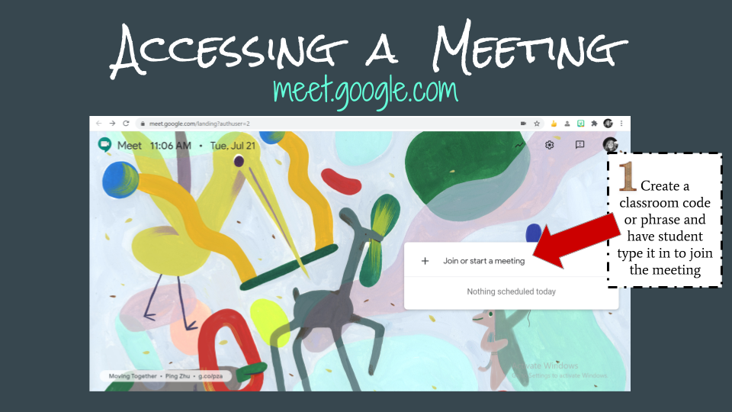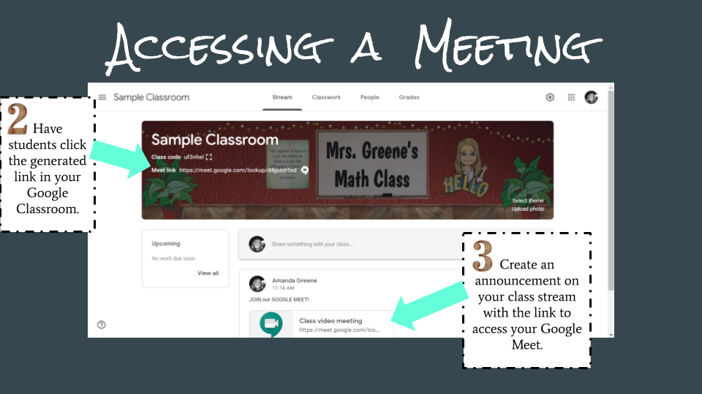
- Website - meet.google.com and enter the code or phrase that the teacher creates
- Click on the Meet Link in the Header of Google Classroom
- Click on the Meet Link the the Announcement section of Google Classroom

4 Important Google Extensions
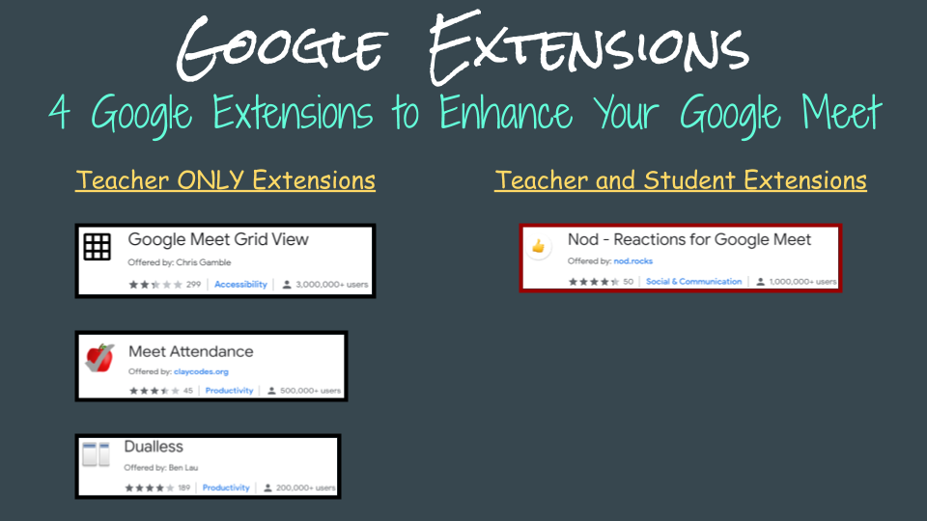
Teacher Extensions
- Grid View - Allows you to see all participants in one grid
- Meet Attendance - Allows teachers to take attendance and sends that spreadsheet to your Google Drive
- Dualless - Allows teachers to split their screen as though they have a dual monitor

Student Extensions
- Nod - Allows students to respond by raising their hand, giving a thumbs up or thumbs down and the use of emojis.

How To Find the Meeting Link and Call In Number
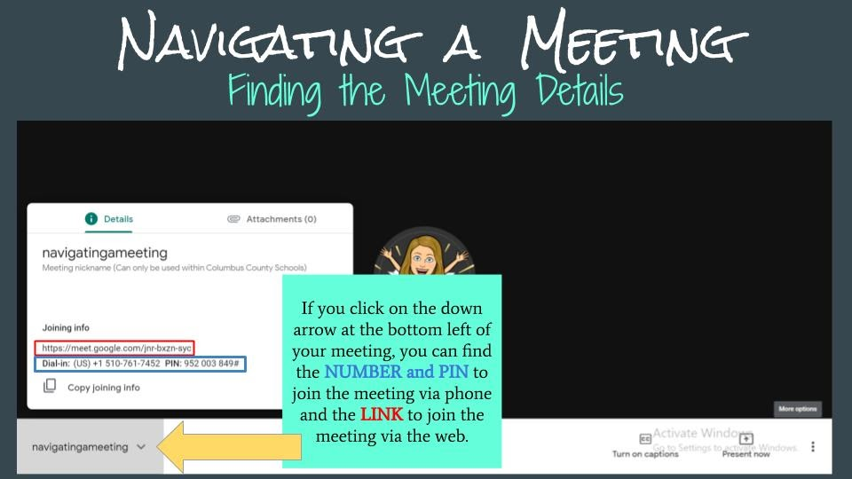

Recording a Google Meet
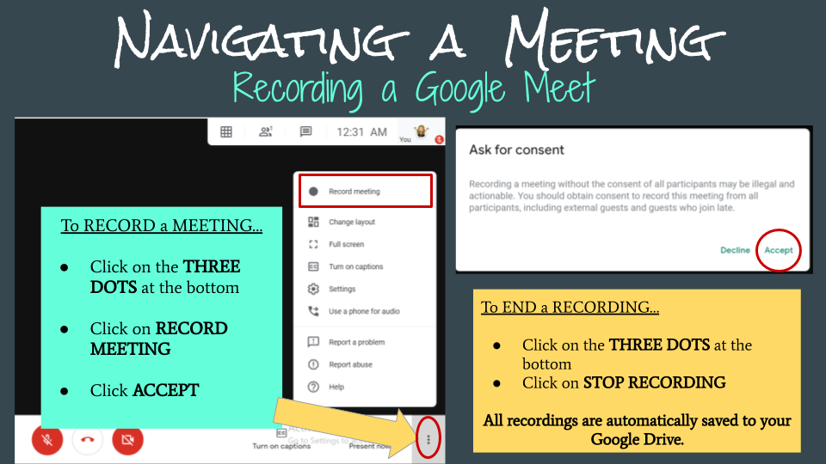

Collaboration in Google Meet
Use the Chat Window for Questions Create Breakout Groups for Student Collaboration
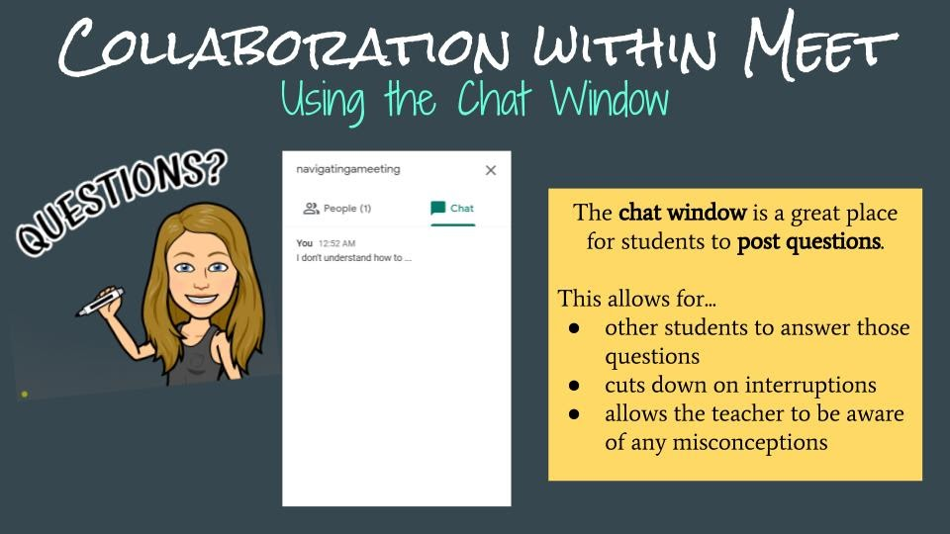
Link to Original Google Slides Presentation https://docs.google.com/presentation/d/1mN6V69JdCxac0NInAkCvuKS9QEvRyHrXTBrDgCLDxPQ/edit?usp=sharing

TEACHER OFFICE HOURS

All teacher planning and office hours should be posted to their Google Classrooms.

UNIFORM DESCRIPTION (Please see CCS Website for exceptions for the 2020-2021SY)
- Shirts:

Colors: White and the two other colors designated for the particular school by the School Uniform Committee
- Shirts must have buttons only.
- Shirts must be collared (turtlenecks are permitted).
- Shirts must be of a solid color.
- Shirts must have sleeves – they may be long-sleeved, short-sleeved or ¾ sleeved.
- Shirts must be free of labels, graphics or insignias of any kind except for the school insignia.
- Shirts must be worn tucked in.
- Midriffs and undergarments cannot be visible and visible cleavage should be minimized. However, students may wear plain white or school color T-shirts under shirts which may be visible at the neckline of the collar.
- Form-fitting spandex material, nylon, denim and see-through or mesh tops are prohibited.

2. Pants/Capris:

Colors: Solid Khaki or Solid Navy Blue or Solid Black
- Pants must have no more than 4 pockets (no cargo pants).
- No over-sized, under-sized or tight-fitting pants.
- Pants must be worn above the hips at all times (no sagging).
- Pants cannot have frays and must be hemmed and not dragging the floor.
- Undergarments cannot be visible.
- Form-fitting spandex material, nylon, denim, blue jeans and sweat pants are prohibited.
- Pants must be free of labels, graphics or insignias of any kind.
- Pants cannot be rolled up to simulate capri pants.
- Pants cannot have a slit that exceeds four inches from the bottom of the pant leg.
- Capri pants cannot have a slit that goes above the knee.

3. Skirts/Jumpers/Dresses/Shorts/Skorts:

Colors: Solid Khaki, Solid Navy Blue, or Solid Black
- Must be no shorter than four inches above the knee.
- Form fitting spandex material, nylon, and denim are prohibited.
- Must be free of labels, graphics or insignias of any kind.
- No more than four pockets.
- Garments cannot have more than two slits and the slits cannot exceed four inches above the knee.
- Undergarments must not be visible.
- One piece jumpsuits are not allowed.

4. Belts:

- Student must wear belts if the garment was manufactured with belt loops; belts must be worn within the belt loops.
- Belts must be black or brown.
- Graphic belts with metal decorations (grommets and studs) are prohibited.
- Belts must be an appropriate length and not hang below the belt loops.

5. Socks:

- Both socks must match.
- Socks must be worn in a manner that does not undermine the integrity of the uniform.
- Socks must be white, black, brown, khaki or navy.
- Socks may not be worn over the pant legs.

6. Shoes/Footwear:

- Shoes/footwear must be worn at all times.
- Shoe laces, if any, must be tied at all times and must be not dragging on the floor.
- Shoe laces, if any, must be white, black or match the color of the shoes.
- Both shoe laces must match and only one lace per shoe.
- Bedroom shoes, slippers, flip flops, shower shoes and spike heels are prohibited.
- Boots may not be worn over the pant leg.
- Sandals (except flip flops) and shoes with velcro are acceptable shoes.

7. Hats, Sunglasses, Headgear, Hoods, Outerwear:

- Sunglasses, hats, (exception: school hat with school logo/insignia) and other headgear are not permitted.
- Kerchiefs, skull caps, sweatbands, do-rags or other items that may be seen as a disruption to the school setting are prohibited.
- No bandanas shall be allowed as an article of clothing and shall not be in the possession of any student. Bandanas will be confiscated and may be submitted to law enforcement officials as possible evidence of gang-related activity.
- No hoods may be worn in buildings.
- Only school affiliated sweat shirts and pull over hoodies are permissible.Sweatshirts of any kind (pullover/hooded) are not permitted.
- Overcoats (heavy weight coats) must be removed when entering the building and are not allowed to be worn inside.
- Sweaters/vest/lightweight jackets are permitted and must be one solid color reflective of the schools colors,in addition to white, black, tan/khaki and navy blue.

8. Jewelry

- No jewelry or any other article affixed to a student’s nose, tongue, lips, cheek, eyebrow, or any other visible part of the body, with the exception of the ears is permissible.
- No articles promoting alcoholic beverages, tobacco, or the use of controlled substances, depict violence, or be of a sexual or disruptive nature are permissible.
- All body art (tattoos) must be covered.
- No large pendants or medallions are permissible.
- No adornment is allowed that reasonably could be perceived as, or used as, a weapon, including, but not limited to chains, spikes and large belt buckles (wider than the belt).

9. Other Uniform Dress Requirements

- No gang-related clothing, accessories, symbols or intimidating manner of dress, as identified by local law enforcement agencies, are allowed.
- No layering of shirts or pants (undergarments and one shirt/pant is allowed).
- Students are expected to be dressed in compliance with the standards for uniforms as established by this policy at all times school is in session.
- Students who are issued uniforms by the school which are used to represent the school in athletic contests approved by the principal or other school sponsored activities may be allowed to wear such uniforms at the discretion of the principal.
- Reasonable accommodations shall be made by the principal for students involved in special duties, activities, or projects approved by the school. This may include, but is not limited to athletics, career and technical education, physical education classes, JROTC, special events, or any other activities that require non-conforming dress on a school campus during a school-sponsored event.

10. School Spirit day

- School spirit T-Shirt day left to the discretion of the principal.

11. Masks

- Masks must be free of any disruptive, obscene, violent, or political statements or images. Appropriateness will be at the Principal’s discretion.

PROMOTION STANDARDS FOR GRADES 3-8, STATE TEST PERFORMANCE
The Standard
In grades K-2 teachers must certify that students are achieving on grade level. These certifications will be based on assessments that correspond to the N.C. Standard Course of Study for each grade.
Students in grades 3-8 who score below Achievement Level III, during the spring administration of the N. C. End-of-Grade Tests in reading or math can be retained in the same grade the following year. Notification to parents that a student has failed to meet the standards in reading or math, will be the responsibility of the student’s teacher. The notice will in writing.

Grades 4-8
The teacher and principal may jointly appeal to have the state test standards waived for a student who has an A, B, or C average on grade level assignments in a subject and who has failed to meet the state test standards.
- Students who have a 60 average or above in the subject area, principal discretion should be utilized. An Appeals Hearing should not be required.
- The teacher and principal must review the work of the student not meeting the standard to determine if a waiver request is appropriate, based on evidence that the student has mastered the N.C. Standard Course of Study for the grade or course in question. Evidence shall include samples of the student’s work referenced to objectives in the N.C. Standard Course of Study. An appeal presented without student work will not be accepted.
- Parents of the student must be notified by the school regarding whether or not an appeal will be made. Parents who disagree with the decision not to appeal may meet with the teacher and principal to ask for reconsideration. If the parents are unsuccessful, they may pursue an appeal on their own. They must collect the evidence described above and support it before the central committee. The student must have an A, B, or C average on grade level assignments in order to be eligible for an appeal.
- The appeal will be made to the principal and teaching staff from the subject area(s) in question. The judgment should be based on the validity of the principal’s and teacher’s contention, through thorough documentation, that the student has mastered the N.C. Standard Course of Study for the curriculum in question.

Parent Responsibilities
Successful student achievement is dependent on the involvement of parents and guardians. Knowledge of the expectations of the school is essential to the successful involvement of parents and guardians. Therefore, by the first scheduled parent conference day, the parents or guardians of each student should meet with their child’s teachers in the core academic areas to receive information about the courses, course requirements and expectations for the year. Parents or guardians should sign at the time of the visit acknowledging receipt of the information and agreeing to be a partner in ensuring the success of their student in school. Parents of new students entering school during the school year should complete this process also. Principals and teachers are encouraged to invite parents to visit again to review the curriculum content covered by end-of-grade testing.

School’s Responsibility for Notifying Parents
The following timelines shall be followed:
- Not later than two weeks after the end of first semester, teachers shall submit to the principal an initial list of children whose promotion is doubtful. Reasons for consideration of retention shall accompany the list.
- The principal shall review the student records. A principal/teacher conference shall be held as soon as possible.
- Parents/guardians of children being considered for retention shall be notified in writing and invited for conferences no later than six weeks after the end of the first semester. Documentation of the parent notification shall be maintained by the teacher.
- During the last grading period, a grade level and/or individual teacher conference shall be held to discuss the academic deficiencies of possible retainees.
- Promotion and/or retention of students who transfer during the school year should not be made until a full review of the student’s records has been completed.
- Parent/guardian concerns should be considered. The final decision regarding promotion/retention, however, shall be made by educators based on student progress, student attendance, and what is best for the student. Per state law, the final decision rests with the principal.
- In grades 3-8, interim report cards shall be issued for all students at the midpoint of each grading period.

GRADING SCALE 2020-2021
A = 100-90 B = 89-80 C = 79 – 70 D = 69 – 60 F = Below 59

ATTENDANCE POLICY(Both Lawful and Unlawful)
- A student in grades K-8 must be in attendance a minimum of one hundred sixty (160) days. (To be counted present, a student must be in school at least one-half (1/2) of the school day--until 11:30 a.m.)
- STUDENTS NOT IN ATTENDANCE FOR 160 DAYS CANNOT BE PROMOTED TO THE NEXT GRADE.
- Digital Learning
  - There must be two-way communication with parents, and/or completed assignments each day to be considered present.
  - Full-time virtual students who do not turn in work for five days will be counted absent for all 5 days. Teachers will notify administration of any 5 day lapse using a method prescribed by the principal.

LAWFUL ABSENCES
Following an absence, the student must bring a signed statement from his/her parent or guardian which gives the date of the absence and the reason for the absence. The student must bring this statement to school on the day of his/her return from the absence. The principal/designee will determine if the absence is lawful or unlawful and code it accordingly. No note results in an unlawful absence; however, if the note is brought on the second day, the absence will be coded.
A lawful absence will allow the student to make up the work that was missed while he/she was away. The student shall be entitled to five school days to make up all missed work. This would include time for testing as arranged by the student at the convenience of the teacher. Any work missed by the student while absent and not turned in will result in no credit for that assignment. Lawful absences include the following:
a. Illness or injury (A statement from a physician may be required at the discretion of the principal.)
b. Quarantine
c. Death in the immediate family
d. Medical or dental appointments (documentation from physician required)
e. Court or administrative proceedings
f. Religious observances
g. Educational opportunity (prior approval and documentation by the principal is mandatory)

UNLAWFUL ABSENCES
Any absence that is not defined or determined lawful by the principal/designee is unlawful. A student may make up any work or evaluations within five days following any absence, whether excused or not. Work missed during an extended absence will be addressed individually. The time and place for the make-up work shall be determined by the principal and teacher. If a student fails to be present for the make-up test(s), then he/she shall receive no credit for the test.
EXCESSIVE TARDINESS AND EARLY CHECK-OUTS
North Carolina State Board of Education Policy states that students must receive 1000 hours of instruction per 180 day period to receive credit. Likewise, students must receive 135 hours of instruction to receive credit for each class in which they are registered. When students are late or leave school early they are missing important instructional time. Therefore, it is imperative that students be in school and in class for the full time allotted. Excused tardies and excused check-outs will require official documentation from a Doctor or Dentist, Judge etc. Notes from parents will not be acceptable.
  - Kindergarten through Grade 8. Three unexcused tardies to school or three unexcused check-outs from school, within a semester, will result in (1) day of unexcused absence from school.
  - High school grades 9 through 12. Three unexcused tardies to class or three unexcused check-outs from class will result in (1) day of unexcused absence from that class.
**Students cannot be check out from school after 2:45 p.m. unless it is an emergency.
MAKE-UP WORK
The school will provide make – up opportunities within five (5) days following any absence, whether excused or not. Work missed during an extended absence will be addressed individually.

EARLY RELEASE/ATTENDANCE / DAILY BELL SCHEDULE
In order to protect instructional time, parents are asked to pick up students early only when necessary. Students are encouraged to attend school regularly, arriving promptly and remaining all day. The school days are 7:45 until 2:50. Students MUST sign in and out through the office. PARENTS ARE ASKED TO PICK UP STUDENTS IN PERSON, NOT BY TELEPHONE. The parent must come to the office and sign the student out of school when leaving early and sign the student in school when arriving late. Students need a note from the office to enter the classroom after the tardy bell. Recent court actions make this necessary. This procedure is to protect your children. STUDENTS MUST BE IN SCHOOL FOR AT LEAST THREE HOURS OF INSTRUCTIONAL TIME TO BE CODED PRESENT FOR THE DAY.

PARENT ADVISORY COUNCIL MEETINGS
The Parent Advisory Council will meet four times annually. These meetings may be virtual or face to face. These meetings will be quarterly: September, November, February, and May. Additional meetings can be held if requested by the Principal or any member of the Parent Advisory Council.

ACCEPTABLE USE POLICY
Every child that receives a chromebook will receive an acceptable use and responsibility contract that has to be completed and signed by the student and parent in order to receive the chromebook. A copy of the chromebook handbook will also be provided.

FEES/MONIES OWED TO THE SCHOOL
All students are responsible for paying school fees as soon as possible at the beginning of the school year. Those students who participate in fundraising activities are responsible for either returning the merchandise or the money in a timely manner. Students who do not take care of these obligations may not be permitted to participate in field trips or other extracurricular activities until fees/monies have been paid or appropriate arrangements have been made with the principal.
School Fees
Instructional Materials $4.00
Physical Education $2.00
Elective $10.00
Careers $5.00
Science $5.00
5th Grade (Recorder) $7.00

COLUMBUS COUNTY SCHOOLS MEAL PRICES
PK – 8th Breakfast/Lunch ............... FREE
Second Student Meals ………... $2.50
Adults: Breakfast ……….. $1.80
Lunch ……….. $3.75

DIABETES STATEMENT
North Carolina’s Senate Bill 911 requires that school have a diabetes care plan for children who are diabetic. The Columbus County Schools are in the process of identifying every child in our system with diabetes and insuring an appropriate plan is in place.
If your child is diabetic, please contact your child’s principal immediately, so a plan for your child’s care at school can be implemented for the 2012-2013 school year.

CHILD FIND STATEMENT
Columbus County Schools is committed to identifying and serving all children with disabilities who are in need of special education and related services. If you know of a child or youth who has been diagnosed or suspected to have a disability, please contact the principal or exceptional children’s director.

TO PARENTS OF STUDENTS
As required by Federal Regulations you are notified by this letter that an Asbestos Management Plan for your school, or workplace, has been developed. It is on file in the Administration office at the school location and is available for the public review. A copy is also on file at the office of the Superintendent and also the plant Operations Department Office.

PARENT CONFERENCES
Conferences with teachers and parents are encouraged but should be scheduled during teacher planning, before school or after school. As much as possible, conferences should be scheduled on Mondays, Tuesdays, and Thursdays. Your cooperation is appreciated. It is also the responsibility of the parent to contact the school when the status of your child changes. It is very important that the school is also updated any time there is a change in contact information, such as phone numbers and email addresses.

PARENT DIGITAL SUPPORT
We do have online support for parents for digital learning concerns. You can call the school at 642-8301. There is also a chat option available to parents on the Columbus County Schools Webpage. Or you can go to Ccsdigital.org. Parents will also receive a copy of their student’s login and password information at the beginning of the school year.
COVID DROP OFF PROCEDURES
Students will be allowed to be dropped off every morning beginning at 7:30. Students will need to be dropped off in front of the main office. They must remain at the vehicle with their parents until the temperatures have been checked, and safety questions asked. If the temperature is 100.4 degrees or higher, or they answer yes to any Covid-19 related questions, they will not be permitted to enter the building.
FIELD TRIPS
Parents must send written permission to school for students to go on school-sponsored field trips. The teacher will notify the parent at least a week in advance about the date of the trip, where they will go, the time of departure, and the expected return time to school. Students owing fees or any other money to the school may not be permitted to participate in field trips until the fees are paid. Students that are in ISS/OSS forfeit the right to participate in field trips. (Field Trip Money is Non-refundable)

FIRE DRILLS
There will be a fire drill during the first five days of school and thereafter, once a month for the remainder of the school year. The centralized fire alarm system notifies the faculty, staff, and students of a drill by sounding a loud alarm. When the alarm is sounded, pupils will rise and leave the room without books and other personal items, walking rapidly. No talking or pushing is allowed and there is to be silence in the hallway and for the duration of the fire drill. The order of leaving the room should be by rows beginning with the row nearest the door. One long ring of the bell will notify the students that they may safely return to their classroom.

DRUGS AND ALCOHOL
No form of drugs, alcoholic beverages, or controlled substances as defined in the General Statutes are allowed to be in the possession of a student during the school day, on school property, or off the school property if involved in a regular school activity. If any of these items are found in a student’s possession during these times, it shall result in the student being subject to 10 days suspension or expulsion. This includes coming to school under the influence.
Any student selling or in any way dispersing alcoholic beverages, narcotic drugs, controlled substances, or misrepresentations of these on the school promises or at any school related function is subject to suspension and/or expulsion. Students will be held on the campus and turned over to the proper authorities.
HEAD LICE FACTS
- ANYONE can get head lice.
- Having head lice does not mean a person is dirty, poor or uneducated.
- Head lice do not cause disease.
- They DO NOT fly or jump. They DO crawl quickly and hide well.
- They DO NOT live long off the human head (12 hours or less).
- They DO NOT infest animals.
- Head lice are about the size of a sesame seed. They are gray or brown and somewhat ‘see-through’. Because lice are good at hiding, it is easier to look for and locate NITS (eggs).
- Nits are white or gray and smooth, with a defined oval shape. They are about the size of a grain of salt and are attached to the sides of strands of hair. Unlike dandruff, nits can NOT be shaken from hair.
As a parent, YOU CAN HELP PREVENT HEAD LICE ON YOUR CHILD’S HEAD and in your child’s school or social group by doing the following:
  - Teach your child not to share combs, brushes, coats, hats, scarves, barrettes, head bands, hair ribbons, hair clips. Also, please teach your child that anyone can get head lice and that teasing should not happen.
  - Check your child’s hair thoroughly each week.
  - If you find something you suspect may be lice or nits, but you are not sure, ask for help from your child’s school, the school nurse, the health department or your child’s doctor as soon as possible.
*Please note—while your child’s doctor can help with identification and treatment, if your child has lice and/or nits, the child must be checked by their school nurse in order to re-enter school. You must be present for your child to re-enter school.
  - If you find lice or nits AND feel confident about what you have found, please tell your child’s school, day care, relatives, playmates’ parents, frequent visitors, sleep-over buddies as soon as possible—so they can all start checking and working to clear-up the problem. When a student is found to have lice/nits, school personnel will inspect the student’s school-aged siblings, classmates, and other close associates. Columbus County School personnel will do everything possible to keep this information private!
  - If you find lice or nits, use the head lice treatment/shampoo of your choice. (Be sure to read the warnings and cautions in order to choose the right product for your child/family). Follow directions exactly!
**Do not overuse chemical treatments. They can not prevent lice, they do not remove nits and they can cause health problems (especially, if misused).If you have questions, please contact the health department, your pharmacist, your child’s doctor or the school nurse.
Spraying (carpet and furniture) is NOT advised (vacuuming is enough and safer).
Columbus County Schools’ Head Lice Policy
Students found to have head lice or nits must be treated for lice. All nits must be removed. Once treated and all nits are removed, the student can only be checked by the school nurse to receive clearance to return to school. Students must return to school as soon as possible!

GARRETT’S LAW (Senate Bill 444)
§ 115C-375.4.Meningococcal Meningitis and Influenza and Their Vaccines.
Local boards of education shall ensure that schools provide parents and guardians with information about meningococcal meningitis and influenza and their vaccines at the beginning of every school year. This information shall include the causes, symptoms, and how meningococcal meningitis and influenza are spread and the places where parents and guardians may obtain additional information and vaccinations for their children. (2005-22,s.4(a), (b).)

In 2007 the General Assembly of North Carolina enacted the following to include HPV:

SECTION 1.G.S. 115C-47 is amended by adding a new subdivision to read:(49) To Ensure that Schools Provide Information Concerning Cervical Cancer, Cervical Dysplasia, Human Papillomavirus, and the Vaccines Available to Prevent These Diseases. –Local boards of education shall ensure that schools provide parents and guardians with information about cervical cancer, cervical dysplasia, human papillomavirus, and the vaccines available to prevent these diseases. This information shall be provided at the beginning of the school year to parents of children entering grades five through 12. This information shall include the causes and symptoms of these diseases, how they are transmitted, how they may be prevented by vaccination, including the benefits and possible side effects of vaccination, and places parents and guardians may obtain additional information and vaccinations for their children."(5/31/07)
You can also receive addition information from the following link.
http://www.immunize.nc.gov/schools/resourcesforschools.htm
DEBORAH GREENBLATT ACT
Permissible Use of Seclusion and Restraints

It is the policy of the State of North Carolina to promote safety and prevent harm to all students, staff, and visitors in the public schools; to treat all public school students with dignity and respect in the delivery of discipline, use of physical restraints or seclusion, and use of reasonable force as permitted by law; to provide school staff with clear guidelines about what constitutes use of reasonable force permissible in North Carolina public schools; to improve student achievement, attendance, promotion, and graduation rates by employing positive behavior interventions to address student behavior in a positive and safe manner; and to promote retention of valuable teachers and other school personnel by providing appropriate training in prescribed procedures which address student behavior in a positive and safe manner.

The following definitions apply in this section: “Assistive technology device’’ means any item, piece of equipment, or product system that is used to increase, maintain, or improve the functional capacities of a child with a disability.
“Aversive procedure’’ means a systematic physical or sensory intervention program for modifying the behavior of a student with a disability which causes or reasonably may be expected to cause one or more of the following: significant physical harm, such as tissue damage, physical illness, or death; serious, foreseeable long-term psychological impairment; obvious repulsion on the part of observers who cannot reconcile extreme procedures with acceptable, standard practice, for example: electric shock applied to the body, extremely loud auditory stimuli, forcible introduction of foul substances to the mouth, eyes, nose, or skin, placement in a tub of cold water or shower, slapping, pinching, hitting, or pulling hair, blindfolding or other forms of visual blocking, unreasonable access to toileting facilities.
“Behavioral intervention” means the implementation of strategies to address behavior that is dangerous, disruptive, or otherwise impedes the learning of a student or others.
“IEP” means a student’s Individualized Education Plan.
“Isolation” means a behavior management technique in which a student is placed alone in an enclosed space from which the student is not prevented from leaving.
“Law enforcement officer” means a sworn law enforcement officer with the power to arrest. Mechanical restraint” means the use of any device or material attached or adjacent to a student’s body that restricts
freedom of movement or normal access to any portion of the student’s body and that the student cannot easily remove.
“Physical restraint” means the use of physical force to restrict the free movement of all or a portion of a student’s body.
“School personnel” means employees of a local board of education, any person working on school grounds or at a school function under a contract or written agreement with the public school system to provide educational or related services to students, any person working on school grounds or at a school function for another agency providing educational or related services to students.
“Seclusion” means the confinement of a student alone in an enclosed space from which the student is physically
prevented from leaving by locking hardware or other means or not capable of leaving due to physical or intellectual incapacity.
“Time-out” means a behavior management technique in which a student is separated from other students for a limited period of time in a monitored setting.

Physical restraint of students by school personnel shall be considered a reasonable use of force when used in the
following circumstances: as reasonably needed to obtain possession of a weapon or other dangerous objects on a person or within the control of a person; as reasonably needed to maintain order or prevent or break up a fight; as reasonably needed for self-defense; as reasonably needed to ensure the safety of any student, school employee, volunteer, or other person present, to teach a skill, to calm or comfort a student, or to prevent self-injurious behavior; as reasonably needed to escort a student safely from one area to another; if used as provided for in a student’s IEP or Section 504 plan or behavior intervention plan; as reasonably needed to prevent imminent destruction to school or another person’s property. Except as set forth in subdivision one of this subsection, physical restraint of students shall not be considered a reasonable use of force, and its use is prohibited. Physical restraint shall not be considered a reasonable use of force when used solely as a disciplinary consequence. Nothing in this subsection shall be construed to prevent the use of force by law enforcement officers in the lawful exercise of their law enforcement duties.

Mechanical restraint of students by school personnel is permissible only in the following circumstances: when used as an assistive technology device included in the student’s IEP or section 504 plan or behavior intervention plan or as otherwise prescribed for the students by a medical or related service provider; when using seat belts or other safety restraints to secure students during transportation; as reasonably needed to obtain possession of a weapon or other dangerous objects on a person or within the control of a person; as reasonably needed for self-defense; as reasonably needed to ensure the safety of any students, school employee, volunteer, or other person present. Except as set forth in subdivision one of this subsection, mechanical restraint, including the tying, taping, or strapping down of a student, shall not be considered a reasonable use of force, and its use is prohibited. Nothing in this subsection shall be construed to prevent the use of mechanical restraint devices, such as handcuffs by law enforcement officers in the lawful exercise of their law enforcement duties.
Seclusion of students by school personnel may be used in the following circumstances: as reasonably needed to respond to a person in control of a weapon or other dangerous object; as reasonably needed to maintain order or prevent or break up a fight; as reasonably needed for self-defense; as reasonably needed when a student’s behavior poses a threat of imminent physical harm to self or others or imminent substantial destruction of
school or another person’s property; when used as specified in the student’s IEP, Section 504 plan, or behavior
intervention plan and the student is monitored while in seclusion by an adult in close proximity who is able to see and hear the student at all times, the student is released from seclusion upon cessation of the behaviors that led to the seclusion or as otherwise specified in the student’s IEP or Section 504 plan, the space in which the student is confined has been approved for such use by the local education agency, the space is appropriately lighted, the space is appropriately ventilated and heated or cooled, the space is free of objects that unreasonably expose the student or others to harm. Except as set forth in subdivision one of this subsection, the use of seclusion is not considered reasonable force, and its use is not permitted. Seclusion shall not be considered a reasonable use of force when used solely as a disciplinary consequence. Nothing in this subsection shall be construed to prevent the use of seclusion by law enforcement officers in the lawful exercise of their law enforcement duties.

Isolation is permitted as a behavior management technique provided that: the space used for isolation is appropriately lighted, ventilated, and heated or cooled; the duration of the isolation is reasonable in light of the purpose of the isolation; the student is reasonably monitored while in isolation; the isolation space is free of objects that unreasonably expose the student or others to harm. Nothing in this section is intended to prohibit or regulate the use of time-out as defined in this section.

The use of aversive procedures as defined in this section is prohibited in public schools. Nothing in this section modifies the rights of school personnel to use reasonable force as permitted under G.S. 115C-390 or modifies the rules and procedures governing discipline under G.S. 115C-391(a).

Each local board of education shall provide copies of this section and all local board policies developed to implement this section to school personnel and parents or guardians at the beginning of each school year. School personnel shall promptly notify the principal or principal’s designee of any use of aversive procedures, any prohibited use of mechanical restraint, any use of physical restraint resulting in observable physical injury to a student, any prohibited use of seclusion or seclusion that exceeds 10 minutes or the amount of time specified on a student’s behavior intervention plan. When a principal or principal’s designee has a personal knowledge or actual notice of any of the events described in this subdivision, the principal or principal’s designee shall promptly notify the student’s parent or guardian and will provide the name of a school employee the parent or guardian can contact regarding the incident. “Promptly notify” means by the end of the workday during which the incident occurred when reasonably possible, but in no event later than the end of the following workday. The parent or guardian of the student shall be provided with a written incident report for any incident reported under this section within a reasonable period of time, but in no event later than 30 days after the incident. The written incident report shall include: the date, time of day, location, duration, and description of the incident and interventions; the events or events that led up to the incident; the nature and extent of any injury to the student, the name of a school employee the parent or guardian can contact regarding the incident.
No local board of education or employee of a local board of education shall discharge, threaten, or otherwise retaliate against another employee of the board regarding that employee’s compensation, terms, conditions, location, or privileges of employment because the employee makes a report alleging a prohibited use of physical restraint, mechanical restraint, aversive procedure, or seclusion, unless the employee knew or should have known that the report was false. Nothing in this section shall be construed to create a private cause of action against any local board of education, its agents or employees, or any institutions of teacher education or their agents or employees or to create a criminal offense.

EDUCATIONAL RECORD DESTRUCTION POLICY
- All confidential records will be maintained in the last school the student attended for five years beyond the twenty-first birthday.
- Public notice of intent to destroy records will be published in April of each year. Citizens will be informed that records may be needed for Social Security, legal proceedings, or other purposes. A copy of the written policy shall be given to eligible students and/or parents at the time of exit from school.
- The policy will be included yearly in each child’s student handbook.
- Copies of student records will be made available to eligible students or parents upon request.
- Litigated inactive records will be forwarded to the Director for Exceptional Children.
- Records scheduled for destruction will be boxed and sent to the Exceptional Children’s Department with an accompanying student roster.
- A student roster of personally identifiable information will be maintained in data base indefinitely. That information shall include full name last school attended, birth date, exceptionality, parent name, address, phone number, exit status, and date of exit.
Destruction of eligible records will be conducted in July of each year.

Title I
Title I is a federally funded program. The No Child Left Behind Act mandated this program provide money to our school district based on families’ income. Title I funding is intended to ensure that all students have a fair, equitable, and sufficient opportunity to reach proficiency on challenging state academic content standards and state academic assessments. In addition, Title I funding is intended to help districts close the academic achievement gap between high and low performing students, especially between minority and nonminority students, and between students of varying socio-economic status.
Individual public schools with more than 40 percent of families qualifying for free and reduced lunch, may use Title I funds, along with other federal, state, and local funds, to operate a school-wide program to upgrade the instructional program for the whole school.
Our Title I School-wide Program Plan requires a comprehensive needs assessment, school-wide reform strategies, highly qualified teachers and staff, parent involvement, and integration of programs to accentuate the current curriculum.

TITLE I BASIC REQUIREMENTS
1. School Parental Involvement Policy: This is done on an annual basis in consultation with parents and must be distributed to all parents.
2. School-Parent Compact: This must be jointly written and distributed to all Title I parents.
3. Annual Parent Meeting: Each year Title I Programs are required to conduct this meeting for the school to explain what the Title I Program is and the rights of parents as defined in the law.
4. Provide Opportunities for Training Parents: The Title I Programs provides parents with opportunities to become partners with the school in promoting the education of their child both at school and at home. This includes parent training sessions, handouts, newsletters and parent conferences.
5. Informing Parents of Student Progress: This includes our Reporting System which encompasses suggestions of needed follow-up for parents and teachers.
6. Parents Right to Know: Parents have the right to request information regarding the professional qualification of classroom teachers and para-professionals.
7. School Report Cards: The Title I Law requires the state to prepare annual reports for all parents and the public on the academic achievement of all districts and public schools in the state.
8. LEP Parent Notification: The Law requires the school to notify parents if their child is placed in a program for LEP students.

PARENT RIGHTS
• Offer a flexible number of meetings for parents
• Provide parents timely information about Title I programs
• Provide parents an explanation of the curriculum, academic assessment, and proficiency levels students are expected to meet
• Provide parents, if requested, opportunities for regular meetings to participate in decisions relating to the education of their children
• Develop a school-family compact jointly with parents. This agreement states the shared responsibility of providing and supporting children’s learning of high-quality curriculum
• Assist parents in understanding academic content and achievement standards
• Provide materials and training to help parents work with their children
• Educate staff in how to work with parents
• Coordinate parental involvement with other programs
• Distribute information in a format and language parents understand
• Provide support for parental involvement activities requested by parents

