

1. In Victorian times it was considered bad luck to sign a Valentine’s Day card.
2. In the middle Ages, young men and women drew names from a bowl to see who would be their Valentine. They would wear this name pinned onto their sleeves for one week for everyone to see. This was the origin of the expression "to wear your heart on your sleeve."
3. More than 35 million heart-shaped boxes of chocolate will be sold for Valentine's Day.
4. 15 percent of U.S. women send themselves flowers on Valentine's Day.
5. The red rose was the favorite flower of Venus, the Roman goddess of love.

INTERESTING FACTS



Basket Ball Games

🏀 Wildcats Basketball 🏀   
  
Jan. 30- Feb. 3 Hallsboro Invitational  
Feb. 9 @ Acme Delco  
Feb. 13 vs Chadbourn (Homecoming)  
Feb. 16 @ Cerro Gordo  
Feb. 20 vs Acme Delco  
Feb. 21 @ Williams Township  
  
\*All games start at 4:00

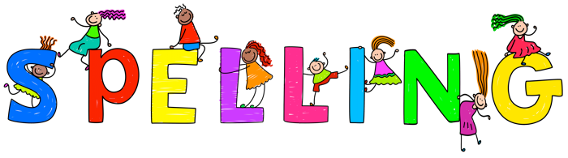

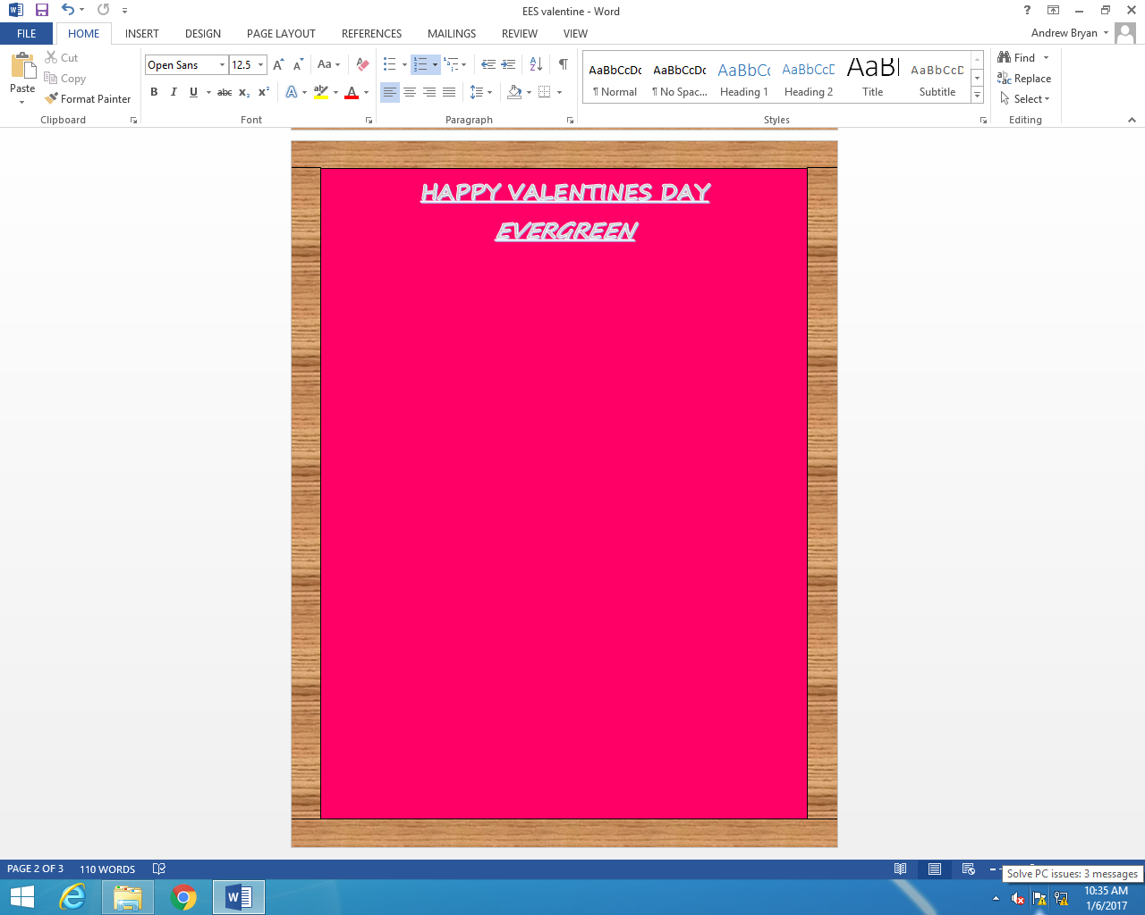

The 2nd graders are working on their spelling, mental math, and reading skills.